TASK | Lubrication of chains and drives
LOCATION OF USE | Workshop and In the field by Mobile Engineers |  | Assessment  No |  | 016
PRODUCT NAME | Action Can Food Grade CD-90 Chain and Drive Lubricant |  |  |  | 016
DESCRIPTION OF SUBSTANCE | Clean no odour no colour lubricant. |  |  |  | 016
MANUFACTURER | Action Can Ltd |  |  |  | 016
MANUFACTURERS CONTACT | Dixon Close,  Old Boston Trading Estate,  Haydock, St Helens  UK WA11 9SF  Tel: 01942 713667  Fax: 01942 713235 |  |  |  | 016
ASSESSOR | Martin Monaghan CMIOSH |  | Date |  | 23 07 26
TITLE | Health and Safety Consultant |  | Review by |  | 23 07 26
Personnel Performing Task  (Please list below)  Technicians/ Fitters/ Workshop Operatives |  | Time Spent  (Minutes/day)  As and when required, amounting to a few minutes per day | Training Given 
 |  |  | Yes

MSDS Revision Date | Hazard Statement
09-07 2014 Rev 2
  H222: Extremely flammable aerosol.
  H229: Pressurised container: May burst if heated.

Assessment to be conducted in Association with Hazard Data Sheets, a full current copy of which must be attached to this assessment.

Please denote the hazardous properties of the substances used in the task with a

NEW INTERNATIONAL GLOBALLY HARMONISED HAZARD SYMBOLS
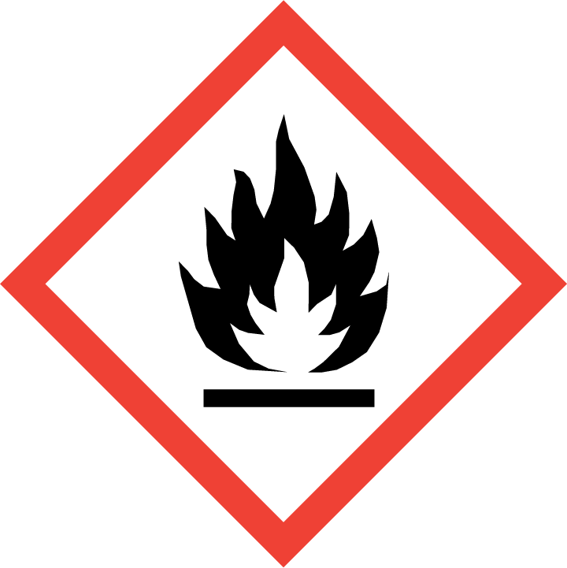 | 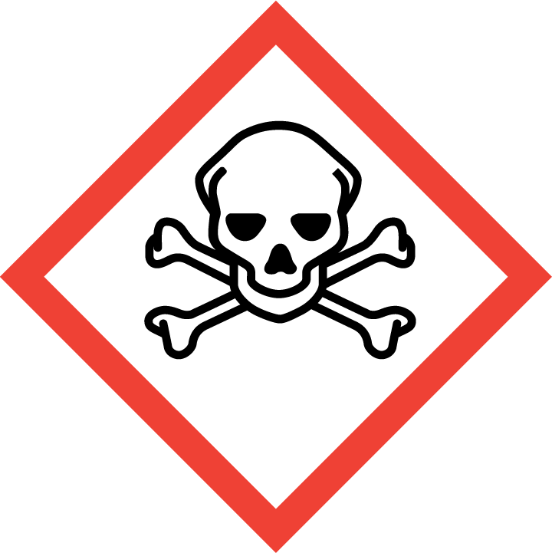 | 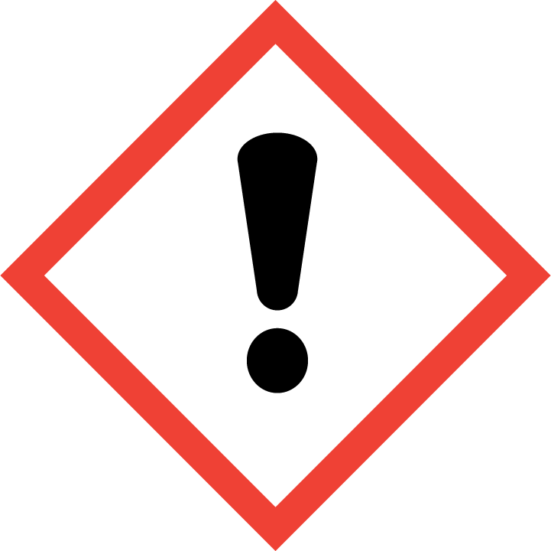 | 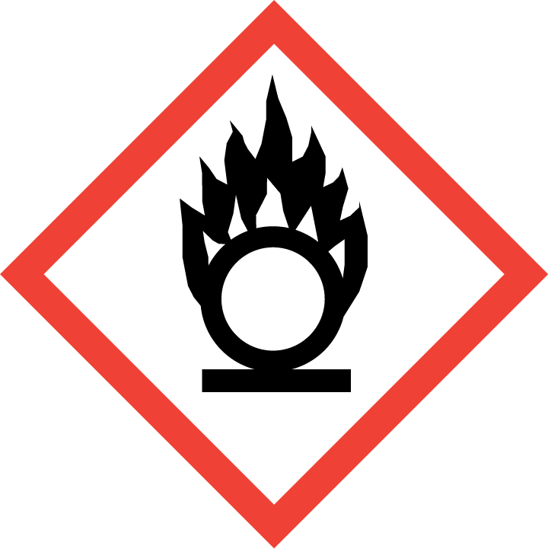 | 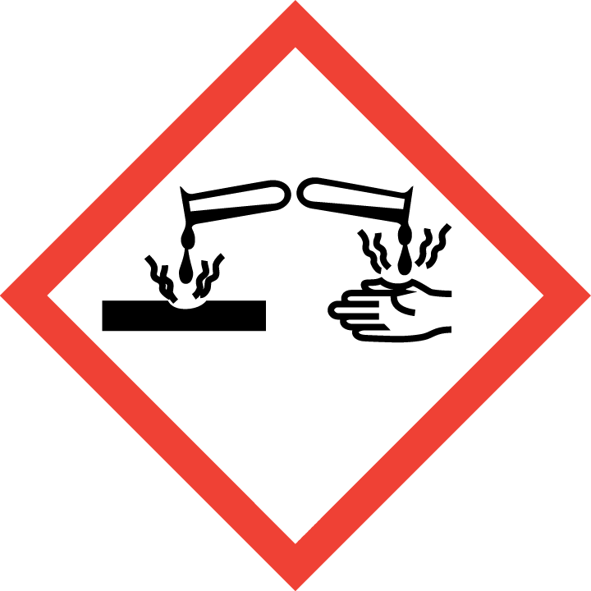 | 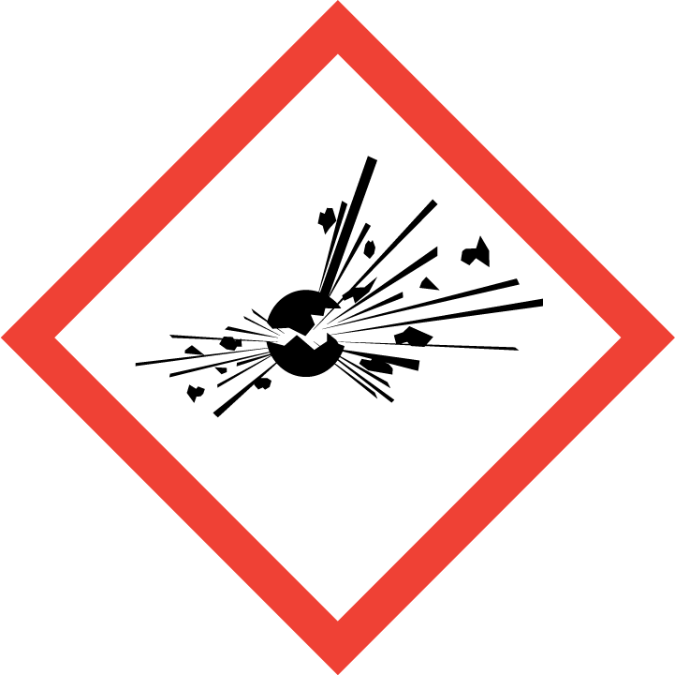 | 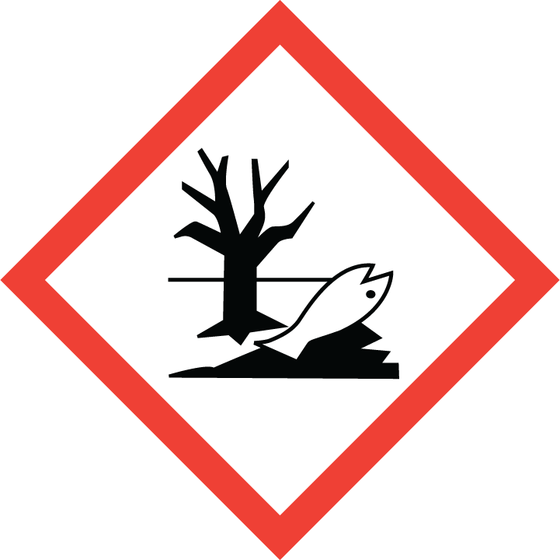 | 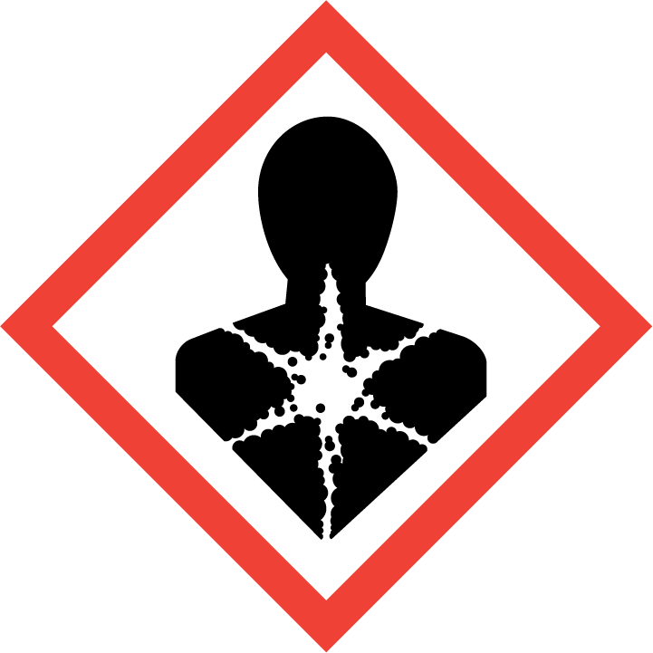
Flammable | Toxic | Harmful | Oxidising | Corrosive | Explosive | Harmful to the environment | Health Hazards i.e. respiratory sensitisation or carcinogenicity

SMOKING, EATING AND DRINKING ARE PROHIBITED IN THE WORK AREAS.
Information, Instruction and Training must be provided to all users. Young Persons, New or Expectant Mothers and other vulnerable groups must not use or be exposed to this product.

WORKPLACE EXPOSURE LIMITS (WEL’s)
The 2 hazardous ingredients in this product is which have a WEL are:

Butane
Mineral Oil

IMPORTANT!
Refer to Workplace Exposure Levels information provided in the Manufacturers Safety Data and revise control measures if exposure levels likely to be reached.

ROUTE OF EXPOSURE
Skin |  | Eyes |  | Inhalation
Ingestion |  | Cuts/abrasions |  | Systemic

PERSONS AT RISK
User of product |  | Co workers |  | Members of the public

ROUTE OF EXPOSURE |   FIRST AID MEASURES
Eyes | Ensure contact lenses are removed, rinse eyes with clean cold water running water for 15 minutes. Refer the patient to an ophthalmologist, in particular if there is any redness, pain or visual impairment.
Skin | Wash skin with soap and water immediately. Not a skin irritant, suggestions made for good industrial practise. If irritation occurs seek medical attention.
Inhalation | Ensure airway is clear and free from any obstruction. Move person to fresh air at once ensuring one’s own safety whilst doing so.
Ingestion | Rinse mouth with water. Do not induce vomiting. In general, no treatment is necessary unless large quantities are ingested. However, get medical advice.
In all cases of doubt, or if symptoms persist seek medical attention. Never give anything by mouth to an unconscious person. If unconscious, place in recovery position and seek medical advice.

PERSONAL PROTECTIVE EQUIPMENT
 |  |  |  | 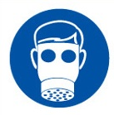 |  | 
YES | YES | YES/NO |  | YES/NO | YES | YES/NO
Safety goggles/glasses are advised if there is a risk of eye contact. | Normal work wear |  |  | No specific recommendation made, but respiratory protection must be used if the  general level exceeds the Workplace Exposure Limit (WEL) | Chemical resistant gloves required for prolonged or repeated contact.

HANDLING | STORAGE | TRANSPORT | DISPOSAL
Ensure the area is well ventilated. Do not pierce or burn aerosols, even after use. Avoid skin and eye contact. Avoid inhalation of vapour, and spray mist. | Store below 50°C in a dry, well- ventilated area away from sources of heat, ignition and direct sunlight. Ensure lighting and electric equipment is not a source of ignition. Keep out of reach of children. Store separately from strong oxidising agents and strongly alkaline and strongly acidic materials. | Flammable aerosols | Send to registered waste disposal site using services of a registered waste disposal contractor. Disposal of packaging: Dispose of as normal industrial waste.

REQUIRED CONTROL MEASURES
- Users to avoid contact with skin and eyes – Use PPE.
- Ensure operatives are made aware of and understand the purpose of this assessment and MSDS, plus any health implications of using the product.
- Ensure COSHH assessments with accompanying MSDS are made available for all employees and users and for inspection and emergency purpose.
- The use of suitable barrier cream is advised, but not as a substitute for gloves.
- Wash promptly if skin becomes contaminated. Wash hands at the end of each work shift and before eating, smoking and using the toilet.

FIRE PRECAUTIONS
Do not use water. Use CO2/Dry foam/Sand. Cool stocks of non- burning product with water mist to reduce possibility of aerosol cans exploding.

Fire will produce smoke containing combustion products which may be a health hazard.

ACCIDENTAL RELEASE/SPILLAGE PROCEDURES
Remove all sources of ignition and ventilate the area. Absorb spillage in suitable inert material such as sand, earth, vermiculite, diatomaceous earth. Do not use equipment for clean- up procedures that produce or cause sparks. Place in a suitable labelled salvage container for disposal by an appropriate method.

MONITORING REQUIREMENTS AND HEALTH SURVEILLANCE
Health surveillance is not in place for workers exposed to this product.

